

FACULTY OF TECHNOLOGY AND ENGINEERING
DEVANG PATEL INSTITUTE OF ADVANCE TECHNOLOGY AND RESEARCH
DEPARTMENT OF INFORMATION TECHNOLOGY

A.Y. 2026-27 [SEMESTER 3]

LAB MANUAL

CEUE203: Object Oriented Programming


Practical 4

Strings, regular expressions, and validation
Problem Statement:
1. Password strength: check four rules and label each password Weak, Medium, or Strong.
2. Chat-log filter: skip malformed lines, match a case-insensitive keyword, and build a report.
3. Template filler: replace named placeholders and use [?] for a missing value.
Expected Output: The sample programs demonstrate the required behavior; see the captured console output below.

Solution:

ChatFilter.java
import java.util.Scanner;
public class ChatFilter {
public static void main(String[] args) {
String[] logs = {"10:05 alice Hello there", "10:06 bob I am online",
"malformed", "10:07 cara Good evening"};
try (Scanner scanner = new Scanner(System.in)) {
System.out.print("Keyword: ");
String keyword = scanner.nextLine().trim().toLowerCase();
int matches = 0;
StringBuilder report = new StringBuilder();
for (String line : logs) {
String[] parts = line.split(" ", 3);
if (parts.length < 3) continue;
if (parts[2].toLowerCase().contains(keyword)) {
matches++;
report.append(parts[0]).append(' ').append(parts[1]).append(": ")
.append(parts[2]).append(System.lineSeparator());
}
}
System.out.println("Matches: " + matches);
System.out.print(report);
}
}
}

PasswordChecker.java
public class PasswordChecker {
private static final String[] RULES = {
"at least 8 characters", "an uppercase letter", "a digit", "a special character"
};
public static String strength(String password) {
int score = 0;
if (password.length() >= 8) score++;
if (password.matches(".*[A-Z].*")) score++;
if (password.matches(".*\\d.*")) score++;
if (password.matches(".*[^a-zA-Z0-9].*")) score++;
return score <= 1 ? "Weak" : score <= 3 ? "Medium" : "Strong";
}
public static void main(String[] args) {
for (String password : new String[]{"abc", "Abcd1234!", "hello123", "OnlyUppercase"}) {
System.out.println("Password: " + password);
boolean[] passed = {password.length() >= 8, password.matches(".*[A-Z].*"),
password.matches(".*\\d.*"), password.matches(".*[^a-zA-Z0-9].*")};
for (int i = 0; i < RULES.length; i++) {
System.out.println(" " + RULES[i] + ": " + passed[i]);
}
System.out.println("Strength: " + strength(password));
}
}
}

TemplateFiller.java
import java.util.regex.Matcher;
import java.util.regex.Pattern;
public class TemplateFiller {
public static void main(String[] args) {
String template = "Dear {name}, order {id} ships {date}.";
String[] names = {"name", "id"};
String[] values = {"Riya", "A07"};
Matcher matcher = Pattern.compile("\\{(\\w+)\\}").matcher(template);
StringBuilder output = new StringBuilder();
int previous = 0;
while (matcher.find()) {
output.append(template, previous, matcher.start());
String replacement = "[?]";
for (int i = 0; i < names.length; i++) {
if (names[i].equals(matcher.group(1))) {
replacement = values[i];
break;
}
}
output.append(replacement);
previous = matcher.end();
}
output.append(template, previous, template.length());
System.out.println(output);
}
}

MiniBank Project Work:

MiniBank progress ? Practical 4
Completed: compiled regex validators, TransactionType and Command records, command parsing with invalid-input checks, and StringBuilder statement formatting.
Single project location: Java Programs\Minibank

Progressive source excerpts:

Minibank/src/main/java/minibank/util/Validator.java
package minibank.util;
import java.util.regex.Pattern;
public final class Validator {
private static final Pattern MOBILE = Pattern.compile("^[6-9][0-9]{9}$");
private static final Pattern EMAIL = Pattern.compile("^[A-Za-z0-9+_.-]+@[A-Za-z0-9.-]+\\.[A-Za-z]{2,}$");
private static final Pattern PAN = Pattern.compile("^[A-Z]{5}[0-9]{4}[A-Z]$");
private static final Pattern IFSC = Pattern.compile("^[A-Z]{4}0[A-Z0-9]{6}$");
private static final Pattern ACCOUNT = Pattern.compile("^AC[0-9]{4,8}$");
private Validator() { }
public static boolean isValidMobile(String value) { return matches(MOBILE, value); }
public static boolean isValidEmail(String value) { return matches(EMAIL, value); }
public static boolean isValidPan(String value) { return matches(PAN, value); }
public static boolean isValidIfsc(String value) { return matches(IFSC, value); }
public static boolean isValidAccountNumber(String value) { return matches(ACCOUNT, value); }
private static boolean matches(Pattern pattern, String value) {
return value != null && pattern.matcher(value).matches();
}
}

Minibank/src/main/java/minibank/model/CommandParser.java
package minibank.model;
public final class CommandParser {
private CommandParser() { }
public static Command parse(String line) {
if (line == null) throw new IllegalArgumentException("Command cannot be null.");
String[] parts = line.trim().split("\\s+");
if (parts.length != 3) {
throw new IllegalArgumentException("Expected: TYPE ACCOUNT_NUMBER AMOUNT");
}
try {
return new Command(TransactionType.valueOf(parts[0].toUpperCase()),
parts[1], Long.parseLong(parts[2]));
} catch (IllegalArgumentException exception) {
throw new IllegalArgumentException("Invalid command type or amount.", exception);
}
}
}

Minibank/src/main/java/minibank/util/StatementFormatter.java
package minibank.util;
import minibank.model.Account;
public final class StatementFormatter {
private StatementFormatter() { }
public static String buildStatement(Account account) {
return new StringBuilder("MINIBANK ACCOUNT STATEMENT\n")
.append("Account: ").append(account.getAccountNumber()).append('\n')
.append("Owner: ").append(account.getOwnerName()).append('\n')
.append("Balance: ").append(account.getBalance()).append('\n')
.append("Interest rate: ").append(account.interestRate()).append("%\n")
.toString();
}
}

Output Screenshot:
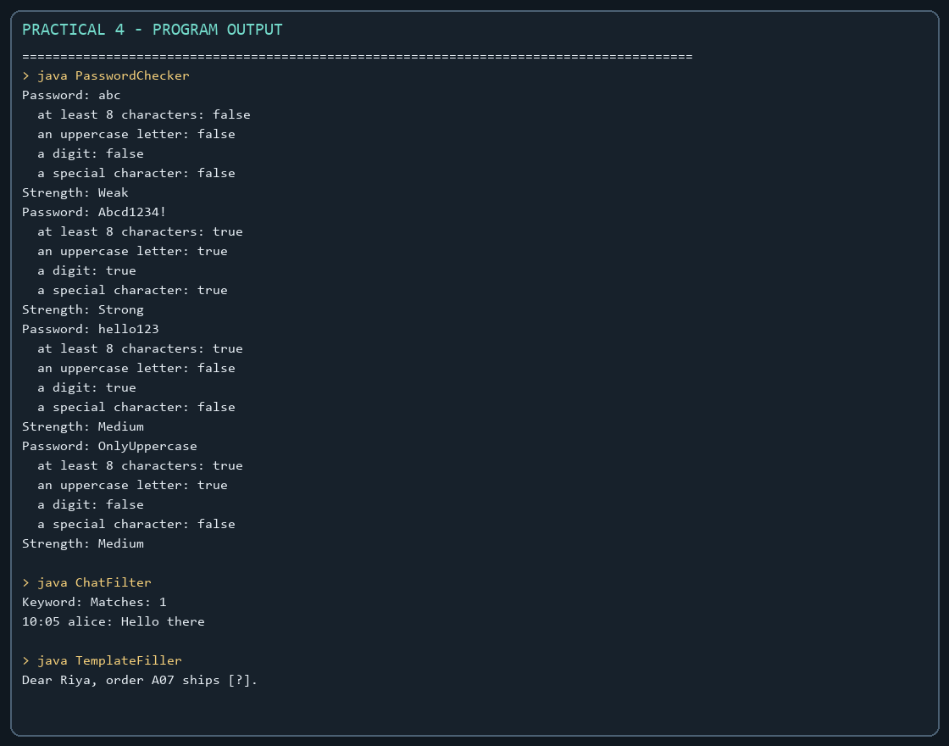
Captured from the compiled practical programs.

